**Markdown for Jupyter notebooks cheatsheet**

[Inge Halilovic](https://medium.com/@ingeh?source=post_page-----386c05aeebed--------------------------------)

**[Inge Halilovic](https://medium.com/@ingeh?source=post_page-----386c05aeebed--------------------------------)**

Beautiful graphs in notebooks are great, but I want my explanatory text to look good too! Somehow I can’t remember all the Markdown tags, so I created this cheatsheet.

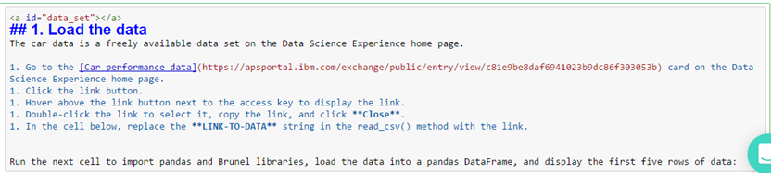

Here’s how to format Markdown cells in Jupyter notebooks in the IBM Data Science Experience.

**Headings**: Use #s followed by a blank space for notebook titles and section headings:  
# title   
## major headings   
### subheadings   
#### 4th level subheadings

**Emphasis**: Use this code: **Bold**: __string__ or **string** *Italic*: _string_ or *string*

**Mathematical symbols**: Use this code: $ mathematical symbols $

**Monospace font**: Surround text with a back single quotation mark. (`) Use monospace for file path and file names and for text users enter or message text users see.

**Line breaks**: Sometimes markdown doesn’t make line breaks when you want them. Use 2 spaces or this code for a manual line break: <br>

**Colors**: Use this code: <font color=blue|red|green|pink|yellow>Text</font> Not all markdown code works within a font tag, so review your colored text carefully!

**Indented quoting**: Use a greater than sign (>) and then a space, then type the text. The text is indented and has a gray horizontal line to the left of it until the next carriage return.

**Bullets**: Use the dash sign (- ) with a space after it, or a space, a dash, and a space ( - ), to create a circular bullet. To create a sub bullet, use a tab followed a dash and a space. You can also use an asterisk instead of a dash, and it works the same.

**Numbered lists**: Start with 1. followed by a space, then it starts numbering for you. Start each line with some number and a period, then a space. Tab to indent to get subnumbering.

**Graphics**: You can attach image files directly to a notebook only in Markdown cells. Drag and drop your images to the Mardown cell to attach it to the notebook. To add images to other cell types, you can use only graphics that are hosted on the web. You can’t add captions for graphics at this time. Use this code: <img src="url.gif" alt="Alt text that describes the graphic" title="Title text" />

**Geometric shapes**: Use this code with a decimal or hex reference number from here: [UTF-8 Geometric shapes](http://www.w3schools.com/charsets/ref_utf_geometric.asp)  
&#reference_number;

**Horizontal lines**: Use three asterisks: ***

**Internal links**: To link to a section, use this code: section title For the text in the parentheses, replace spaces and special characters with a hyphen. Make sure to test all the links!

Alternatively, you can add an ID for a section right above the section title. Use this code: <a id="section_ID"></a> Make sure that the section_ID is unique within the notebook.

Use this code for the link and make sure to test all the links! section title

**External links**: Use this code and test all links! [link text](<http://url>)

# 12 Things to know about Jupyter Notebook Markdown

## This article is about how to write jupyter notebook markdown.

[](https://medium.com/@dcaichara?source=post_page-----3f6cef811707--------------------------------)

[Dayal Chand Aichara](https://medium.com/@dcaichara?source=post_page-----3f6cef811707--------------------------------)

[Apr 15, 2019](https://medium.com/game-of-data/12-things-to-know-about-jupyter-notebook-markdown-3f6cef811707?source=post_page-----3f6cef811707--------------------------------) · 4 min read

Jupyter notebook is in trend among data enthusiasts because it is easy to use, and it allows to create and share documents that contain live code, equations, visualizations and narrative text. Jupyter notebook is used for data cleaning and transformation, numerical simulation, statistical modeling, data visualization, machine learning, and much more.

Markdown writing skills are necessary to represent your work in jupyter notebook to provide enough explanation to reader about code and concept. In this article, you will learn how to write a good jupyter notebook markdown. I will cover 12 important things which will make you markdown expert. Let’s start.

Press **ESC** key to exit jupyter notebook cell. Press **M** to convert jupyter code cell to jupyter markdown.

1. **Headers**

# header 1  
## header 2  
### header 3  
#### header 4

Output:

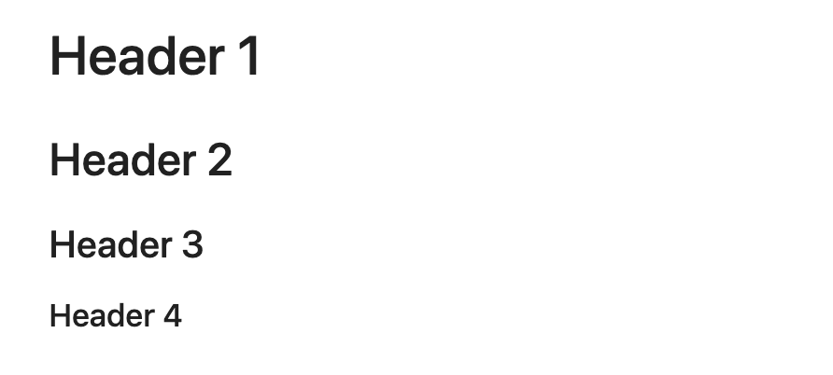

2. **Horizontal Line**

**Use any of three to draw a horizontal line.**   
***   
---  
___

Output:



3. **Text formatting**

Text formatting is important in order to highlight important keywords.

a. **Text color**

<span style='color:green'> message/text </span>  
Example:   
<span style='color:Blue'> Blue is my favorite color. </span>

Output:



b. **Text background**

<span style='background:yellow'> message/text </span>  
Example:   
## <span style='background :yellow' > Background color is yellow </span>

Output:

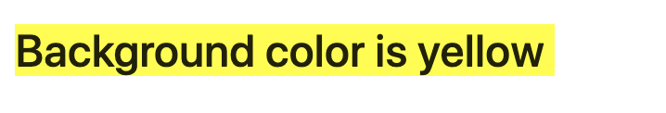

c. **Text font-family**

<span style='font-family:font_family name'> message </span>  
Examples:## <span style='font-family:Georgia'> It is Georgia font.## <span style='font-family:Helvetica'> It is Helvetica font.## <span style='font-family:"Times New Roman"'> <span styel=''>It is "Times New Roman" font.## <span style='font-family:serif'> It is serif font.## <span style='font-family:sans-serif'> It is sans-serif font.

Output:

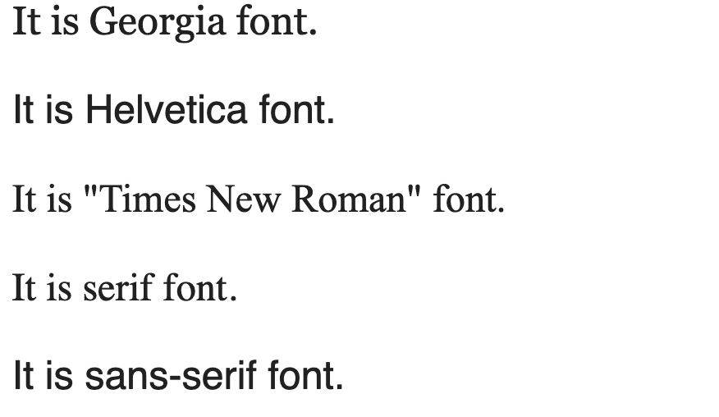

d. **Text Emphasis**

*Italic* or _Italic_   
**Bold**   
***Bold and Italic***   
~~Scratch Me.~~

Output:

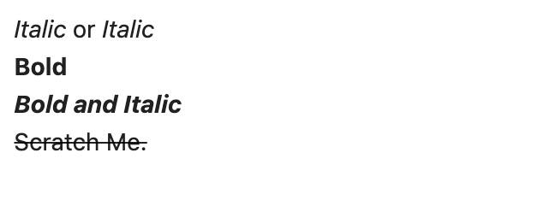

f. **Text in code style**

`print('Hello World')`

Output:

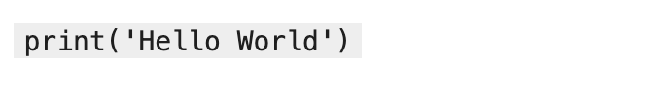

4. **Blockquotes**

> 1 Blockquotes  
>> 2 Blockquotes  
>>> 3 Blockquotes  
>>>> 4 Blockquotes  
>>>>>>>> 8 Blockquotes

Output:

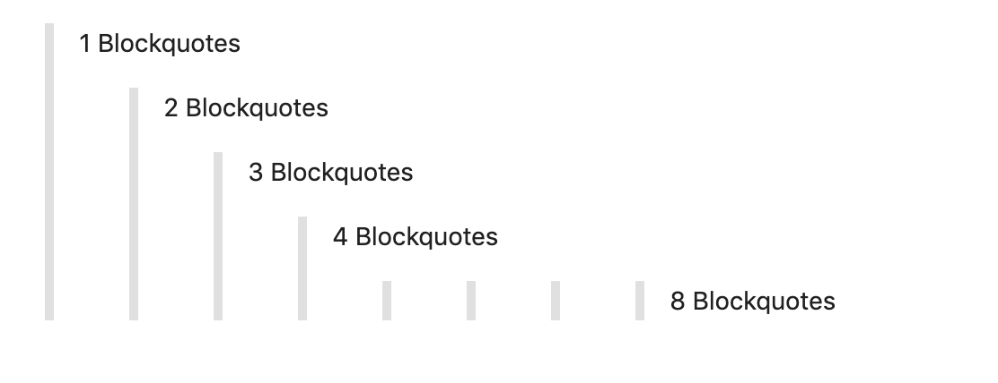

5. **List**

1. Main list <br>  
a. Sub-list <br>  
b. sub list   
2. Main list  
* main list

Output:



6. **Table**

| How | To | Make | a table|  
| :---: | :---: | :---: | :---: |  
| in | <span style= 'background:yellow'> Jupyter </span>| <span style= 'background:yellow'> Notebook </span>| <span style= 'background:yellow'> Markdown </span> |  
| It | is | really| cool |

**Note:** Colons can be used to align columns.  
:--- Left align  
---: Right align   
:---: Center align

Output:

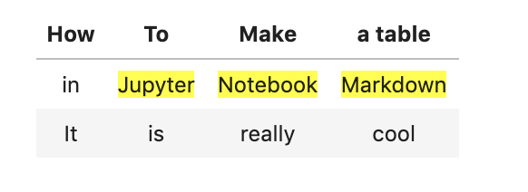

7. **Image insertion**

![](c0ban_logo.png)

Output:



8. **Link insertion**

[My LinkedIn link ](<https://www.linkedin.com/in/dcaichara/>)

Output:



9. Y**ouTube Video**

[![YouTube Video Link]([http://img.youtube.com/vi/YOUR_YUOTUBE_VIDEO_ID/0.jpg)](http://www.youtube.com/watch?v=YOUR_YUOTUBE_VIDEO_ID](http://img.youtube.com/vi/jqSuaRpCnro/0.jpg)%5d(http:/www.youtube.com/watch?v=jqSuaRpCnro)))Example: [![YouTube Video Link]([http://img.youtube.com/vi/jqSuaRpCnro/0.jpg)](http://www.youtube.com/watch?v=jqSuaRpCnro](http://img.youtube.com/vi/jqSuaRpCnro/0.jpg)%5d(http:/www.youtube.com/watch?v=jqSuaRpCnro)))

Output:



If you click on image it will redirect you to youtube link address.

10. **Image Link**

[![photo link](DCA.jpg)]([https://www.linkedin.com/in/d](https://www.linkedin.com/in/dayal-chand-aichara-9311759b/)caichara)

Output will be input image. If you click on image it will redirect you to link addresses.

11. **Syntax highlighting**

```python  
A = "Python syntax highlighting"  
print(A)  
for i in range(0,10):  
 print(A)  
```

Output:

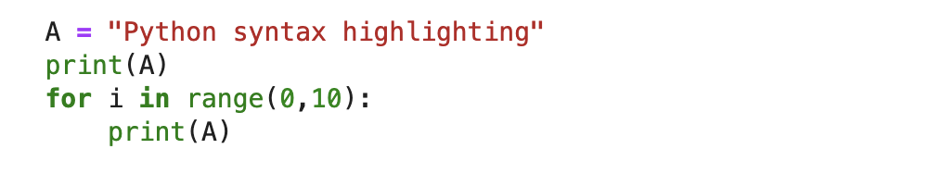

12. **Creating navigation within Jupyter Notebook**

# Target cell  
<a id =integer> </a> # Navigation button  
textExample:  
 <a id =6> </a> <br> Start of Notebook Start of NoteBook

Output:

Click on the blue text line to go where black text line starts.

That’s it. I hope, this article will help to write a better markdown in jupyter notebook. You can find complete code on [GitHub](https://github.com/dc-aichara/Juputer-Notebook-Markdown). You can also download [jupyter notebook markdown cheatsheet](https://github.com/dc-aichara/Juputer-Notebook-Markdown/blob/master/cheatsheet/Jupyter%20Notebook%20Markdown%20Cheatsheet.pdf). Please, reach out to me on [twitter](https://twitter.com/dc_aichara) or [LinkedIn](https://www.linkedin.com/in/dcaichara/) in case you have any query.